

DHOLE PATIL COLLEGE OF ENGINEERING WAGHOLI, PUNE- 412207

A

PROJECT REPORT ON

TOURS AND TRAVEL MANAGEMENT

SUBMITTED BY

VAISHNAVI VISHWASRAO EXAM NO:721541417L

ANJALI PANDIT EXAM NO:72153932H

KALYANI EXAM NO:72154008C

in partial fulfillment for the award of the degree

OF

BACHELOR OF ENGINEERING IN INFORMATION TECHNOLOGY AT

Savitribai Phule Pune University, Pune

Under The Guidance of Prof. NEHALI SHINDE

DEPARTMENT OF INFORMATION TECHNOLOGY 2021-2022



DHOLE PATIL COLLEGE OF ENGINEERING WAGHOLI, PUNE- 412207

DEPARTMENT OF INFORMATION TECHNOLOGY

# CERTIFICATE

This is to certify that,

VAISHNAVI VISHWASRAO EXAM NO: 72154147L

ANJALI PANDIT EXAM NO: 72153932H

KALYANI EXAM NO: 72154008C

Have successfully completed the project entitle “Tours and Travel Management” in partial fulfillment for the award of the degree of Bachelor of Engineering in Information Technology of

Savitribai Phule Pune University during the academic year 2021-2022. The project report had been approved as it satisfies the academic requirements in respect to Project work prescribed by the said degree.

Date:- 24-05-2022

Place:-DPCOE

Prof. Nehali Shinde (Project Guide)

Prof. Rahul Ghode (Head of Department)

**CONTENTS**

**Serial No. Title Page no.**

1. Abstract
2. Acknowledgement
3. Introduction
   1. Existing System
   2. Drawbacks of the existing system
   3. Proposed system
   4. Advantages of the proposed system
4. Modules
   1. Admin authentication
   2. User registration
   3. Package creation
   4. Package booking
   5. Booking confirmation/ manage
5. Software Requirements
6. Hardware Requirements
7. Input and Output
   1. Inputs
   2. Outputs
8. Access control for Data which requires User Authentication
   1. User name (USER)
   2. Password (PASS)
   3. Benefits
9. ER Diagram
10. DFD (Data Flow Diagram)
11. Screenshot
12. Future Scope
13. Objective
14. References
15. Conclusion

**ABSTRACT**

The **“TOURS AND TRAVEL MANAGEMENT SYSTEM”** is a software development. This project is used to automate all process of the travel and tourism, which deals with creation, booking and confirmation and user details. The project is designed HTML-PHP as front end and SQL Server as backend which works in any browsers. The coding language used HTML, CSS and PHP. Travel and tourism management system is used to book a tour from anywhere in the world by a single dynamic website which will help the user to know all about the places and tour details in a single website. The admin can add packages to the website from a certain travel agents and hotels by create a tour page. Then the users can sign in and book each project, they can be confirmed by the admin in their manage booking page. The user can see the confirmation in their my booking page. It is an easiest platform for all travelers which can be easily booked and know the all details.

Keywords: Travel and tourism management, travel packages, tourism, package booking.

**ACKNOWLEDGEMENT**

The completion of Project brings with and sense of satisfaction, but it is never completed without thanking the persons who are all responsible for its successful completion. First and foremost, we wish to express our deep sincere feelings of gratitude to our Institution, **Dhole Patil College of Engineering**, for providing us an opportunity to do our education.

We are thankful to **Prof. Nehali Shinde,** Department of Information Technology and Engineering, Dhole Patil College of Engineering, for her constant support and motivation.

Finally, we would like to thank all the Teaching, Technical faculty and supporting staff members of Department of Information Technology and Engineering, Dhole Patil College of Engineering, Pune, for their support.

**INTRODUCTION**

Travel and tourism management system is used to book a tour from anywhere in the world by a single dynamic website which will help the user to know all about the places and tour details in a single website. The admin can add packages to the website from a certain travel agents and hotels by create a tour page. Then the users can sign in and book each project, they can be confirmed by the admin in their manage booking page. The user can see the confirmation in their my booking page. It is a easiest platform for all travelers which can be easily booked and know the all details. Tour Management system is a dynamic website for tourism business. It is dynamic and responsive web design. It is also called travel technology solution for agencies & tour operation. Nearly Everyone goes on a vacation for this ‘**a Tourism management system**’ would play a vital role in planning the perfect trip. The tourism management system allows the user of the system access all the details such as location, events, etc. The main purpose is to help tourism companies to manage customer and hotels etc. The system can also be used for both professional and business trips.

**EXISTING SYSTEM**

In the existing system, each task is carried out manually and processing is also a tedious job. In previous system travelers were maintaining time table details manually in pen and paper, which was time taking and costly. The travelers is not able to achieve its need in time and also the results may not accurate. Because of the manual maintenance there are number of difficulties and drawbacks exist in the system. Some of them are

**Drawbacks of the Existing System:**

• Increased transaction leads to increased source document and hence maintenance becomes difficult.

• If any admin, user entry is wrongly made then the maintenance becomes very difficult.

**PROPOSED SYSTEM**

The proposed system is designed to be more efficient than the manual system. It invokes all base tasks that are now carried out manually, such as the forms transactions and reports which is added advantage. The proposed System is completely computer-based application. Thousands of records can searched and displayed without taking any significant time.

**Advantages of the Proposed System:**

• Gives accurate information

• Simplifies the manual work

• It minimizes the documentation related work

• Provides up to date information

• Friendly Environment by providing warning messages.

• Travelers details can be provided

• Booking confirmation notification

**Modules**

1. **Admin authentication**

This module is mainly based on admin. System will check the admin user name and password for authentication. After the verification for authorization the admin can be able to precede the process. All works are done under his control.

1. **User Registration**

This module covers the details about the registration of users which they can be register by itself by adding data like name, password, email id and further details. After registration they can be sign in by their username and password.

1. **Package Creation**

The admin can create packages by creating package page which the type, price, details, place details all the travel tour package details can be added here. Which it will be showed in user homepage.

1. **Package booking**

In this module maintain the booking of travel packages by the user by selecting a package.

1. **Booking confirmation/manage**

Booking confirmation is the process of confirming the booked packages by the admin that is booked by the user with date and comment. Also admin can manage the booking by cancelling.

**SOFTWARE REQUIREMENTS:**

**A major element in building a system is the section of compatible software since the software in the market is experiencing in geometric progression. Selected software should be acceptable by the firm and one user as well as it should be feasible for the system. This document gives a detailed description of the software requirement specification. The study of requirement specification is focused specially on the functioning of the system. It allows the developer or analyst to understand the system, function to be carried out the performance level to be obtained and corresponding interfaces to be established.**

**1) Technology Implemented: Apache Server.**

**2) Language Used: DBMS, HTML, PHP, JAVA SCRIPT, CSS or newer versions.**

**3) Database: MySQL XAMPP Server.**

**4) User Interface: HTML, DBMS, CSS.**

**5) Web Browser: Mozilla, Chrome or Internet Explorer 8(or newer).**

**6) Software: Apache & MySQL Server & XAMPP.**

**7) Operating System: Windows 7 or Higher Versions.**

**HARDWARE REQUIREMENTS:**

**The section of hardware configuration is an important task related to the software development. Insufficient random-access memory may affect adversely on the speed and efficiency of the entire system. The process should be powerful to handle the entire operations. The hard disk should have sufficient capacity to store the file and application.**

**1) Users Processor**: **Intel(R) Core (TM) i5-10300H CPU @ 2.50GHz.**

**2) System Memory: 128 MB minimum (256 MB recommended) Cache size: 512 KB.**

**3) RAM: 512 MB (Minimum).**

**4) Network Card: Any card can provide a 100mbps speed Network connection: UTP or Coaxial cable connection Printer: Inkjet/Laser Color printer provides at least 1000 Dpi Hard disk: 80 GB.**

**5) Mouse: 104 keys US Key Serial, USB or PS/2.**

**INPUT AND OUTPUT**

The major inputs and outputs and major functions of the system are follows:

**Inputs:**

* Admin enter his user id and password for login.
* User enters his user id and password for login.
* New users give his completed personnel, address and phone details for registration.
* Admin gives different kind of user information for search the user data.
* User gives his user id, hint question, answer for getting the forgotten password.
* Employee search for flight booking status
* Administrator search for visa processing status.

**Outputs:**

* Admin can have his own home page.
* Users enter their own home page.
* The user defined data can store in the centralized database.
* Admin will get the login information of a particular user.
* The new user’s data will be stored in the centralized database.
* Admin get the search details of different criteria.
* User can get his forgot password.
* Travelling details can be displayed to the employees
* Administrator got visa processing completion documents.

**ACCESS CONTROL FOR DATA WHICH REQUIRE USER AUTHENTICAION**

The following commands specify access control identifiers and they are typically used to authorize and authenticate the user (command codes are shown in parentheses)

**USER NAME (USER)**

The user identification is that which is required by the server for access to its file system. This command will normally be the first command transmitted by the user after the control connections are made (some servers may require this).

**PASSWORD (PASS)**

This command must be immediately preceded by the user name command, and, for some sites, completes the user’s identification for access control. Since password information is quite sensitive, it is desirable in general to “mask” it or suppress type out.

**BENEFITS:**

The project is identified by the merits of the system offered to the user. The merits of this project are as follows: –

* It’s a web-enabled project.
* This project offers user to enter the data through simple and interactive forms. This is very helpful for the client to enter the desired information through so much simplicity.
* User is provided the option of monitoring the records he/she

entered earlier. He /she can see the desired records with the

variety of options provided by him/her.

* Through these features it will increase the efficiency, accuracy and transparency.

**ER DIAGRAM**

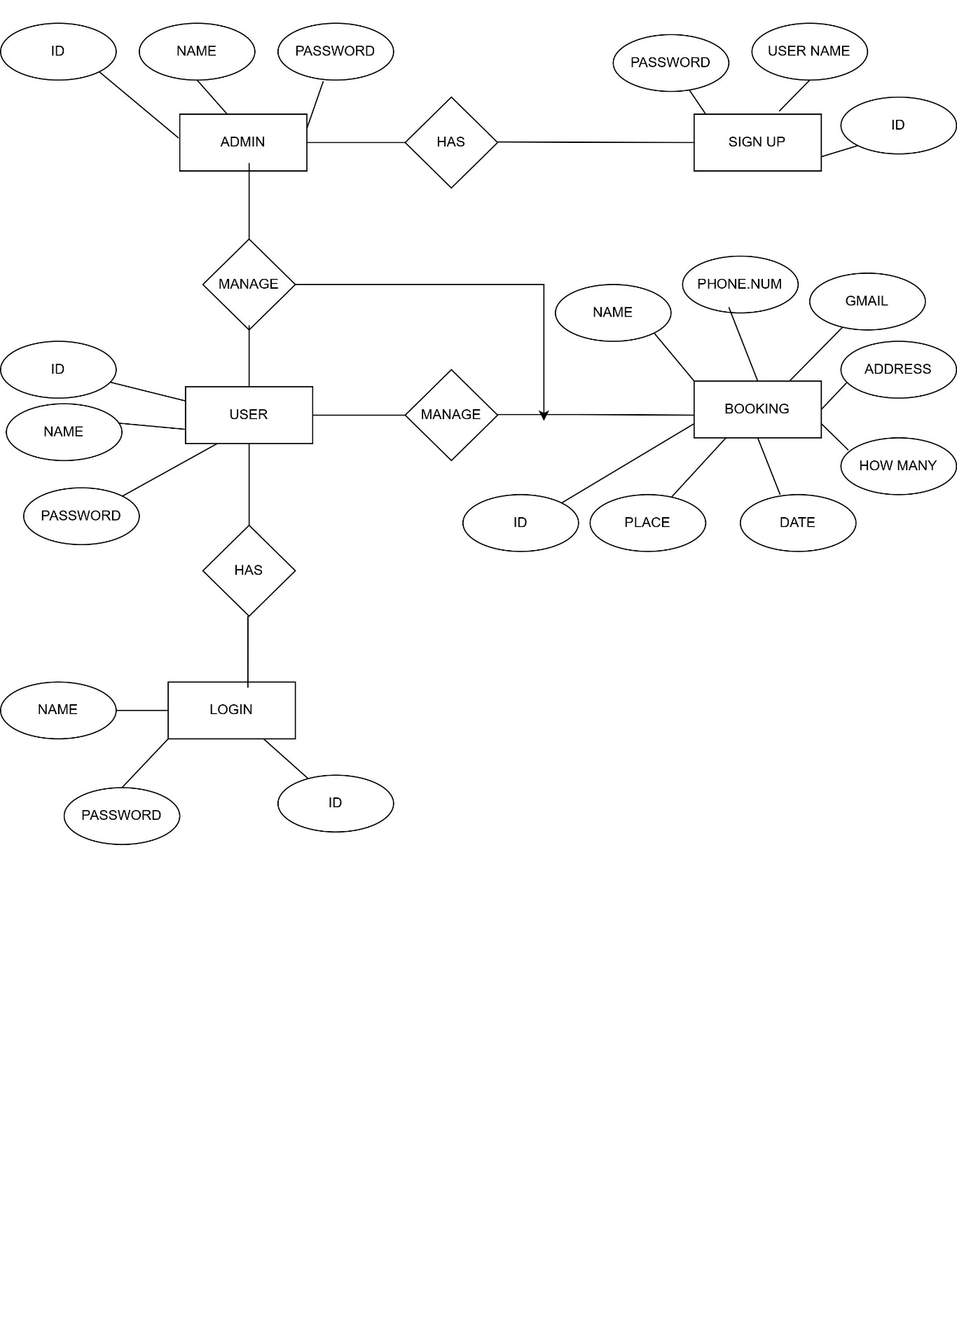

**DFD (Data Flow Diagram)**

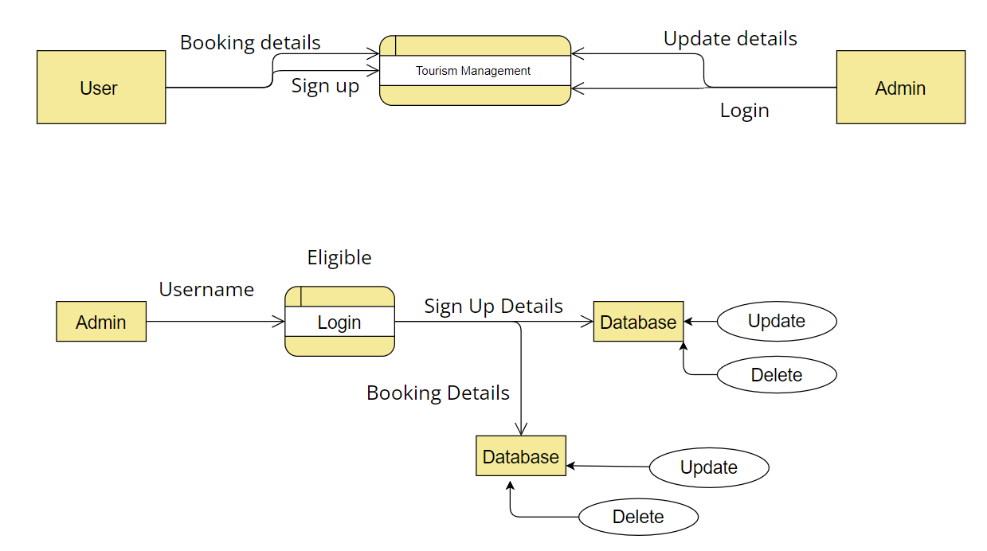

**SCREENSHOT**

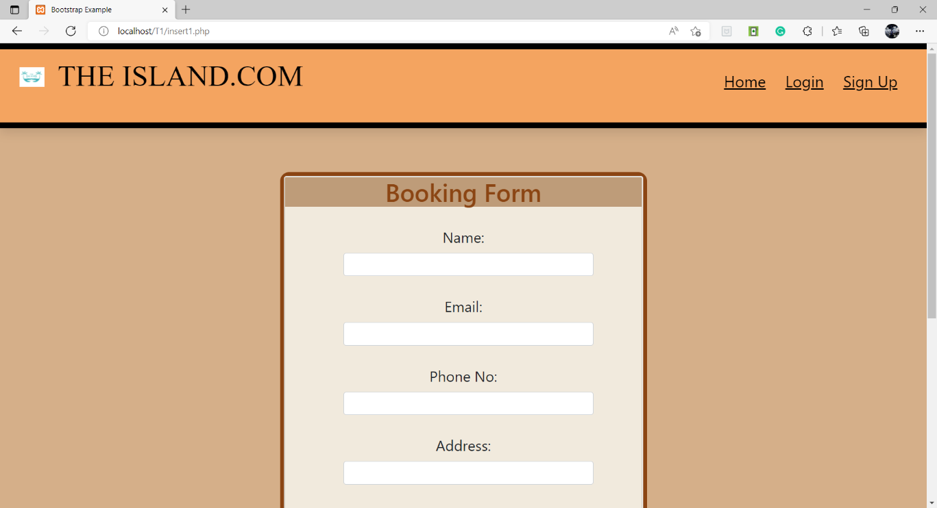

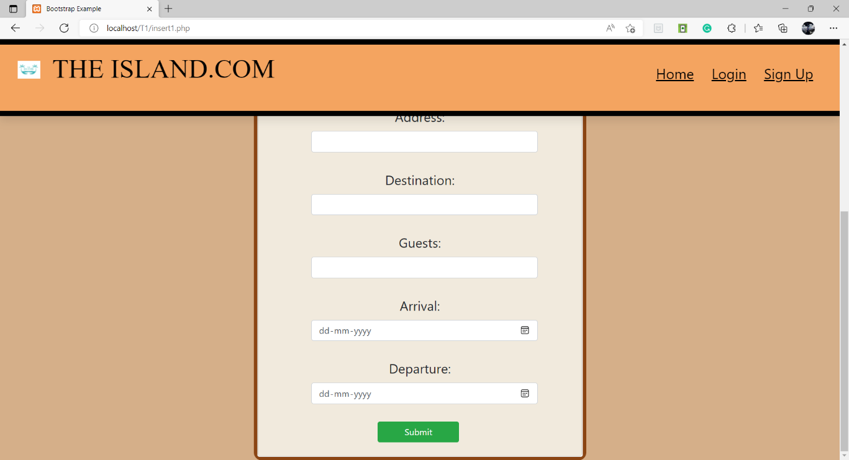

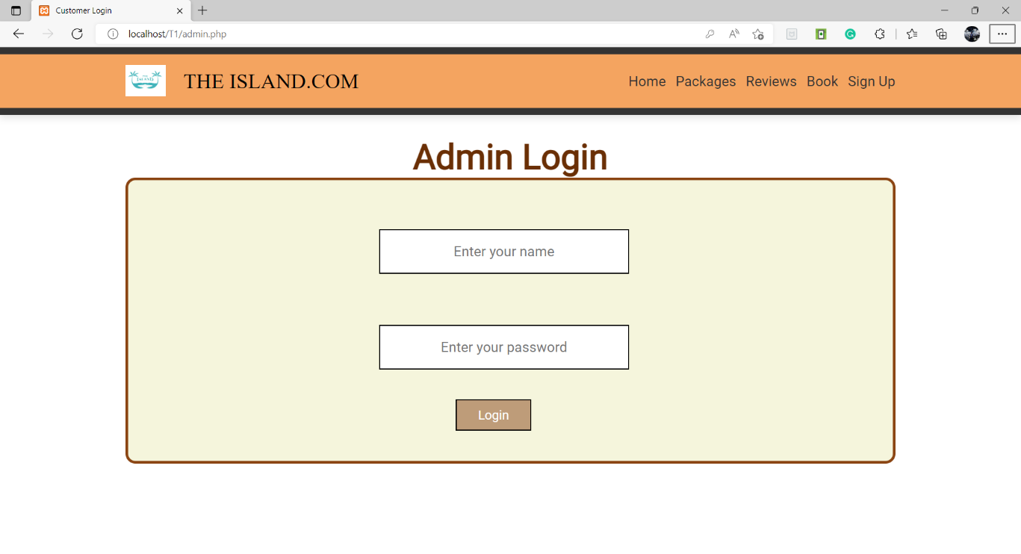

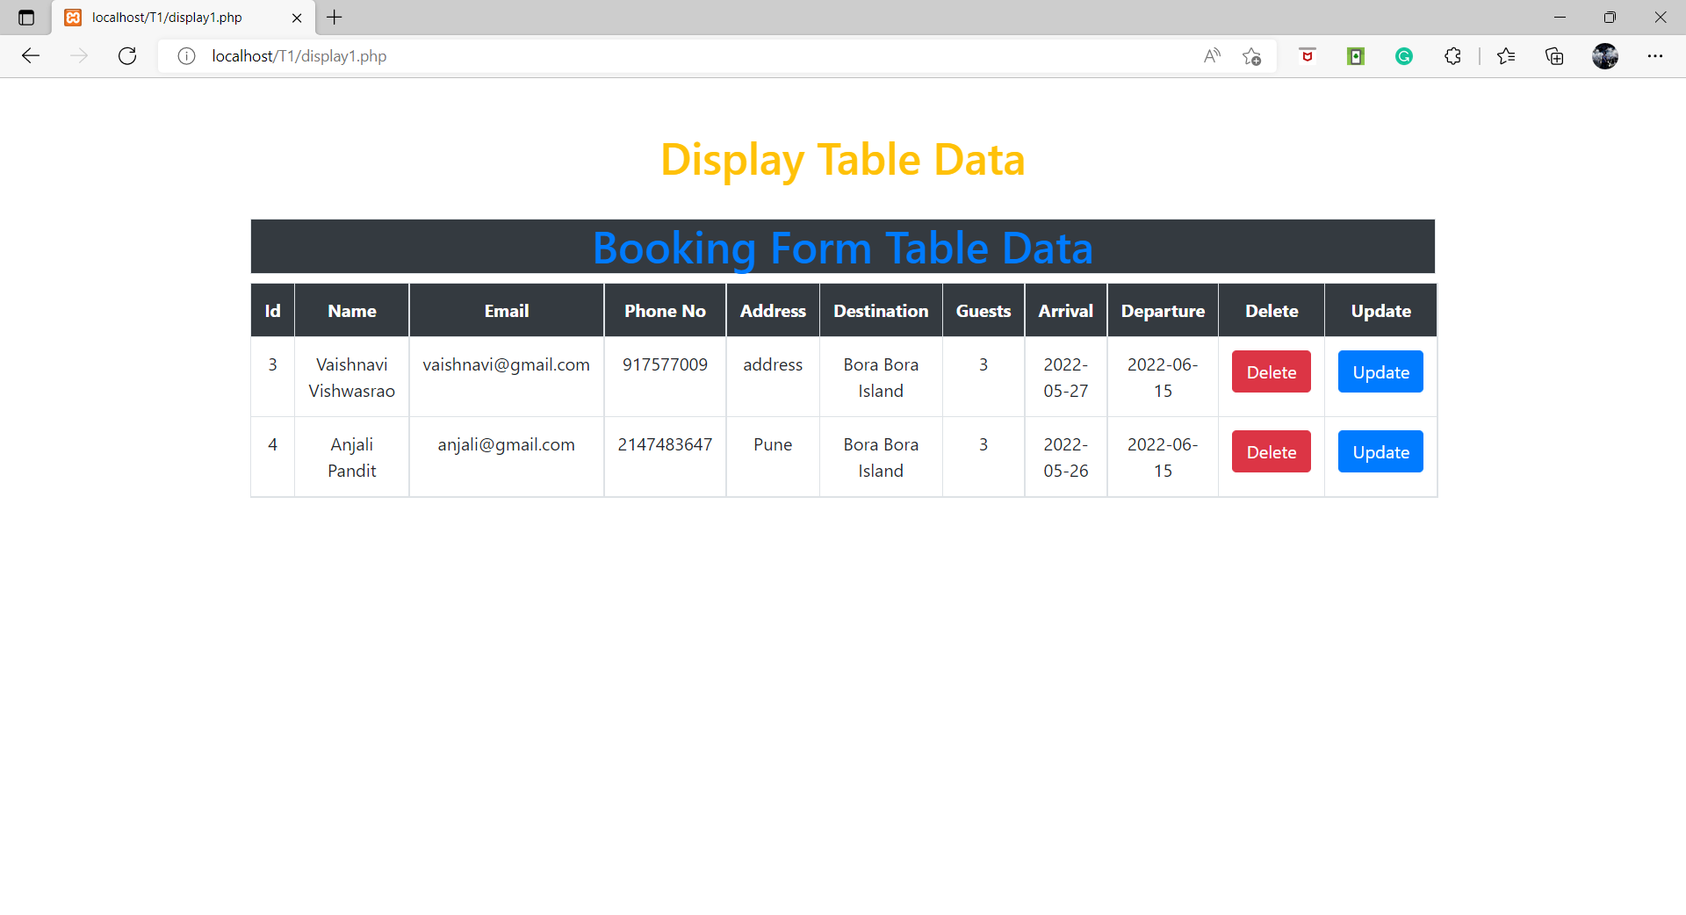

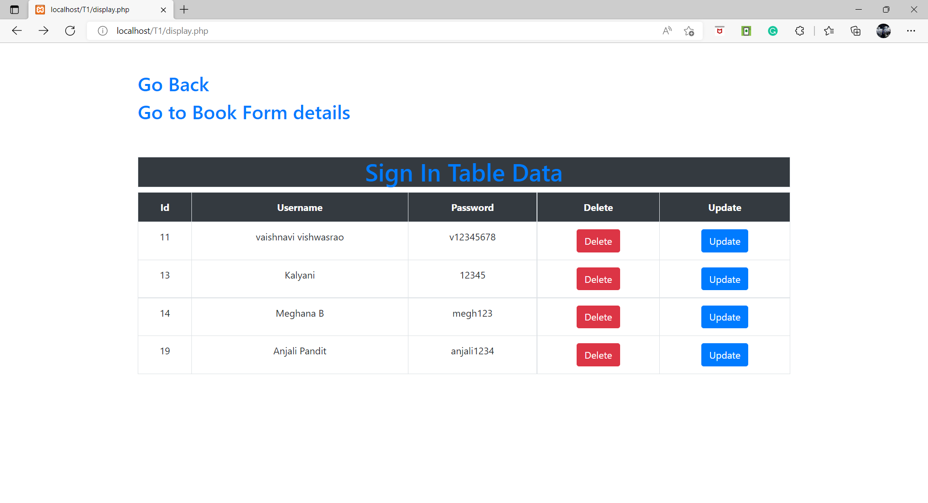

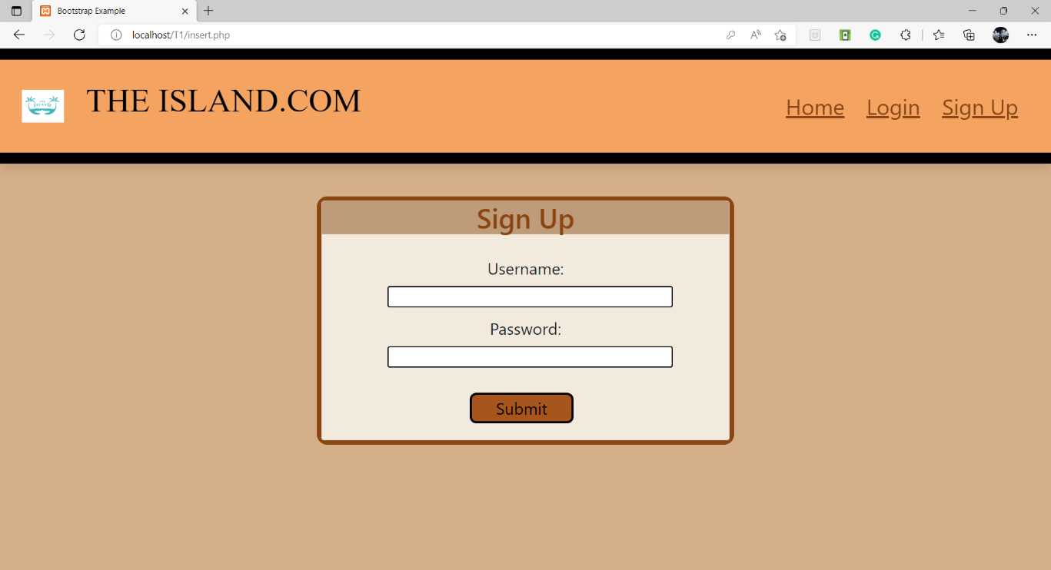

**FUTURE SCOPE**  
  
• Tourism is growing and so is the scope in tourism increasing. There is a good employment in the tourism sector. Thus too grab such opportunities you need to prepare yourself with the knowledge in tourism.

• Any tourist agency can make use of it for saving customer details in database.

• Tourism group can use it for managing their location, hotel, vehicles details.

• This application can easily implemented under various situations.

• We can add new features as and when we require.

• Reusability of this application is also possible.

**OBJECTIVE:**

The objective of the Travel and Tourism Management System project is to develop a system that automates the processes and activities of a travel and the purpose is to design a system using which one can perform all operations related to traveling.

**REFERENCES:**

1.https://www.w3schools.com/bootstrap4/bootstrap_get_started.asp

2.https://cdnjs.com/libraries/font-awesome

3.https://getbootstrap.com/docs/4.3/components/forms

4.https://getbootstrap.com/docs/4.0/components/navbar/

5.https://github.com/bootstrap

6.https://developer.mozilla.org/en-US/docs/Web/API/CSSStyleSheet3

7.https://youtu.be/34MBVXsDOtA

8.https://www.tripadvisor.in/Tourism-g311415-Bora_Bora_Society_Islands-Vacations.html

9.https://www.tahiti.com/island/bora-bora

10. https://www.google.com/search?q=bora+bora+island&client=ms-android-xiaomi-rvo2&prmd=minv&sxsrf=ALiCzsbf93iYxCBG53k1g4Oj5K7iQ5fL9g:1653374195189&source=lnms&tbm=isch&sa=X&ved=2ahUKEwiZ3dbswvf3AhXYzYsBHWnTBqIQ_AUoAnoECAIQAg&biw=393&bih=689&dpr=2.75

**CONCLUSION**

This web application was successfully created and stored all the travel admin tourism packages booking, creation managing and tour details into the database using this application. The application was tested very well and the errors were properly debugged. Testing also concluded that the performance of the system is satisfactory. All the necessary output is generated. This system thus provides an easy way to automate all the functionalities of consumption. If this application is implemented in few consumption, it will be helpful. Further enhancements can be made to the project, so that the website functions in a very attractive and useful manner than the present one. It is concluded that the application works well and satisfy the needs. The application is tested very well and errors are properly debugged. It also acts as the sharing of files to the valuable resources.